1 Sales by Customer <https://us1.ca.analytics.ibm.com/bi/?perspective=explore&pathRef=.my_folders%2Fsales_by_customer&subView=model000001837e4917ff_00000000>

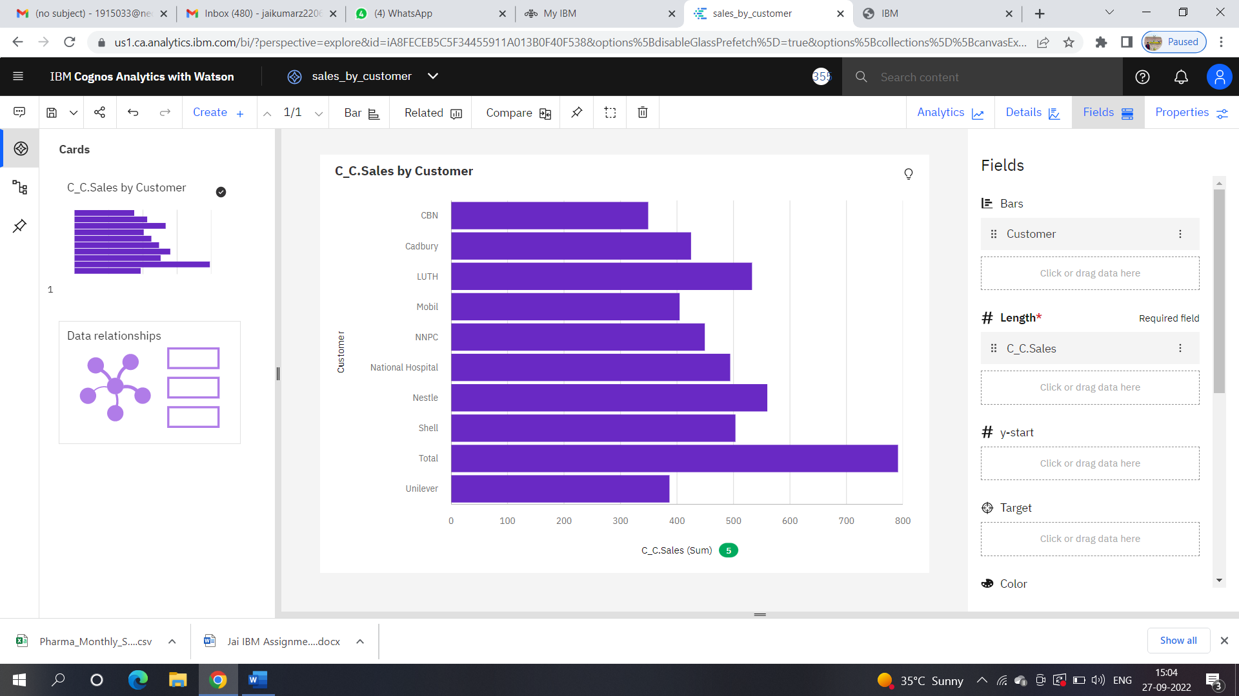

2 Sales by location <https://us1.ca.analytics.ibm.com/bi/?perspective=explore&pathRef=.my_folders%2Fsales_by_location&subView=model000001837e4c84e0_00000001>

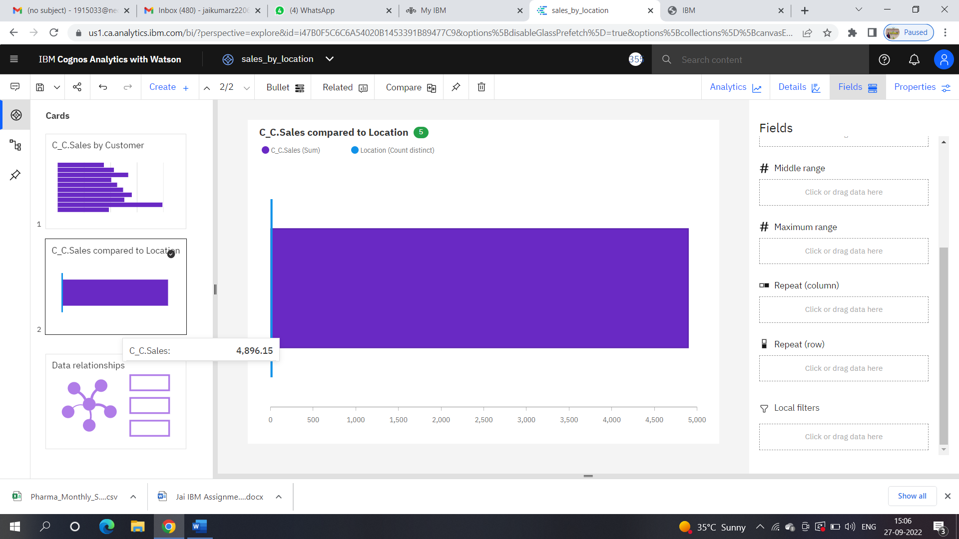

3 Sales by sales Representative <https://us1.ca.analytics.ibm.com/bi/?perspective=explore&pathRef=.my_folders%2Fsales_by_Rep.sales&subView=model000001837e4f0cd1_00000000>

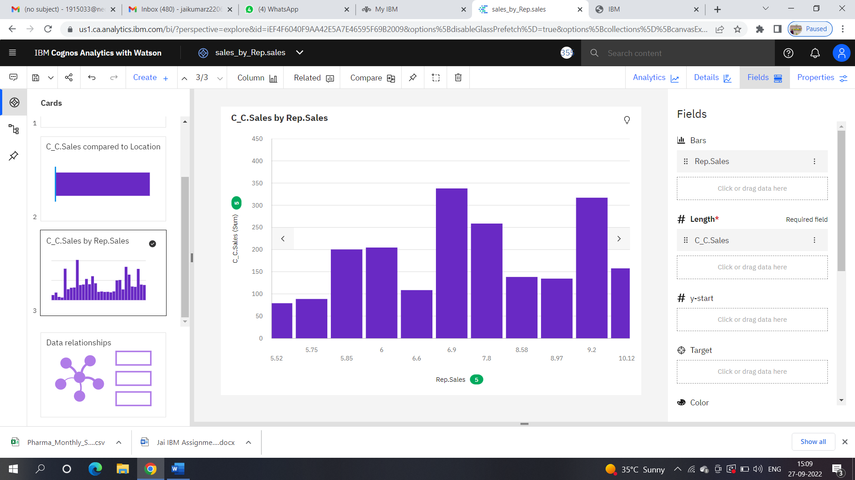

4 Rececived Inventory from Supplier <https://us1.ca.analytics.ibm.com/bi/?perspective=explore&pathRef=.my_folders%2FReceived%2Binventory%2Bfrom%2Bsupplier&subView=model000001837e518cc1_00000002>

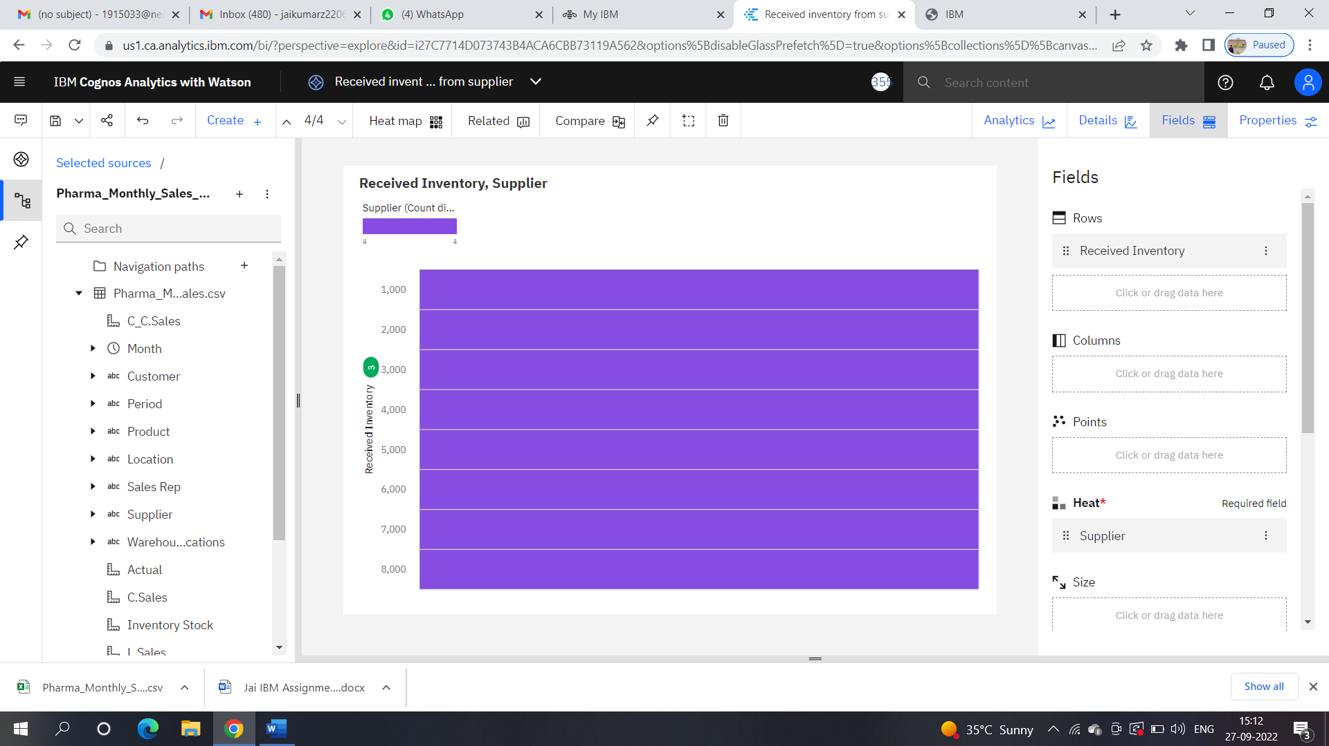

5 Inventory Stock for Warehouse Location <https://us1.ca.analytics.ibm.com/bi/?perspective=explore&pathRef=.my_folders%2FInventory%2BStock%2Bfor%2BWarehouse%2BLocations&subView=model000001837e5382fb_00000004>

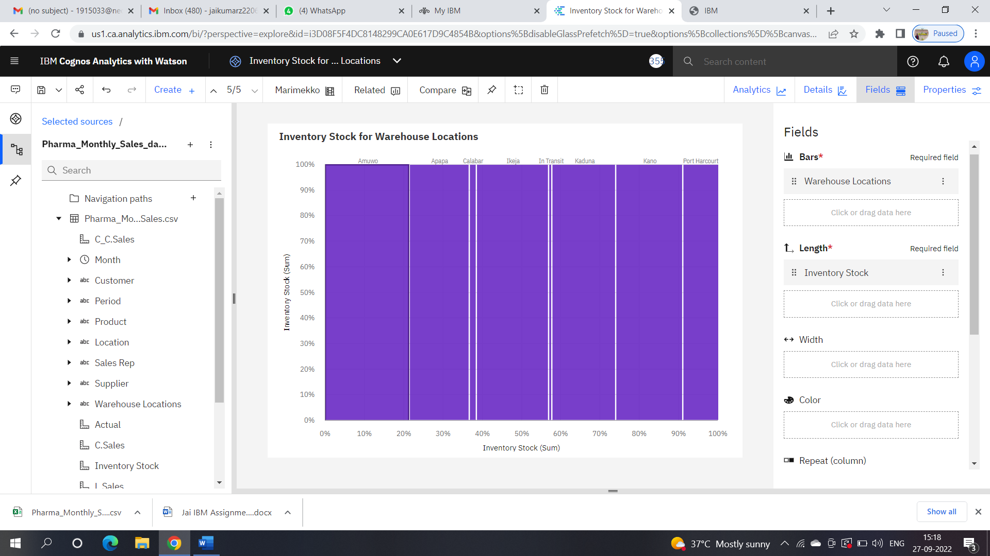

6.Sales Trend <https://us1.ca.analytics.ibm.com/bi/?perspective=explore&pathRef=.my_folders%2Fsales%2Btrend&subView=model000001837e58d3e0_00000000>

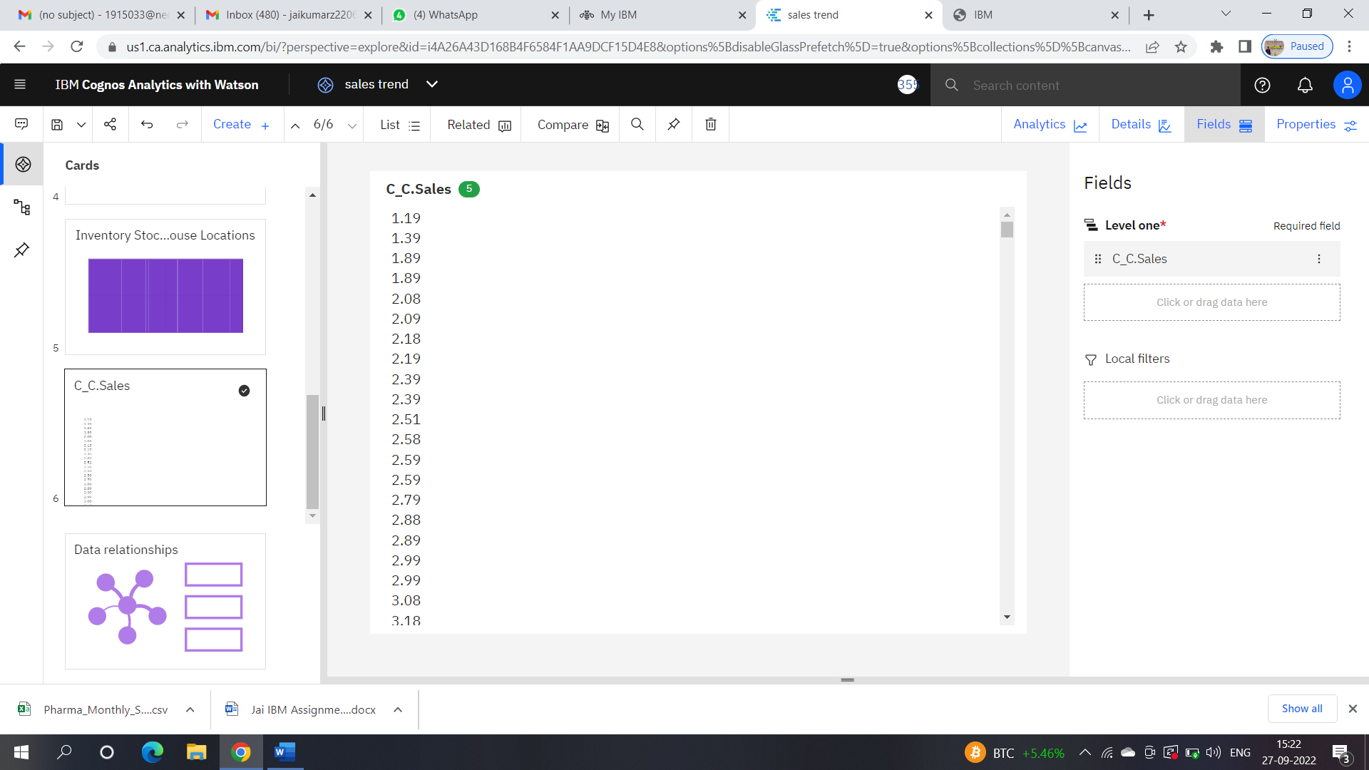

[7 Monthly Sales https://us1.ca.analytics.ibm.com/bi/?perspective=explore&pathRef=.my_folders%2FMonthly_sales&subView=model000001837e5ca336_00000004](https://d.docs.live.net/e9f1de4322680905/Documents/7%20Monthly%20Sales%20https:/us1.ca.analytics.ibm.com/bi/?perspective=explore&pathRef=.my_folders%2FMonthly_sales&subView=model000001837e5ca336_00000004)

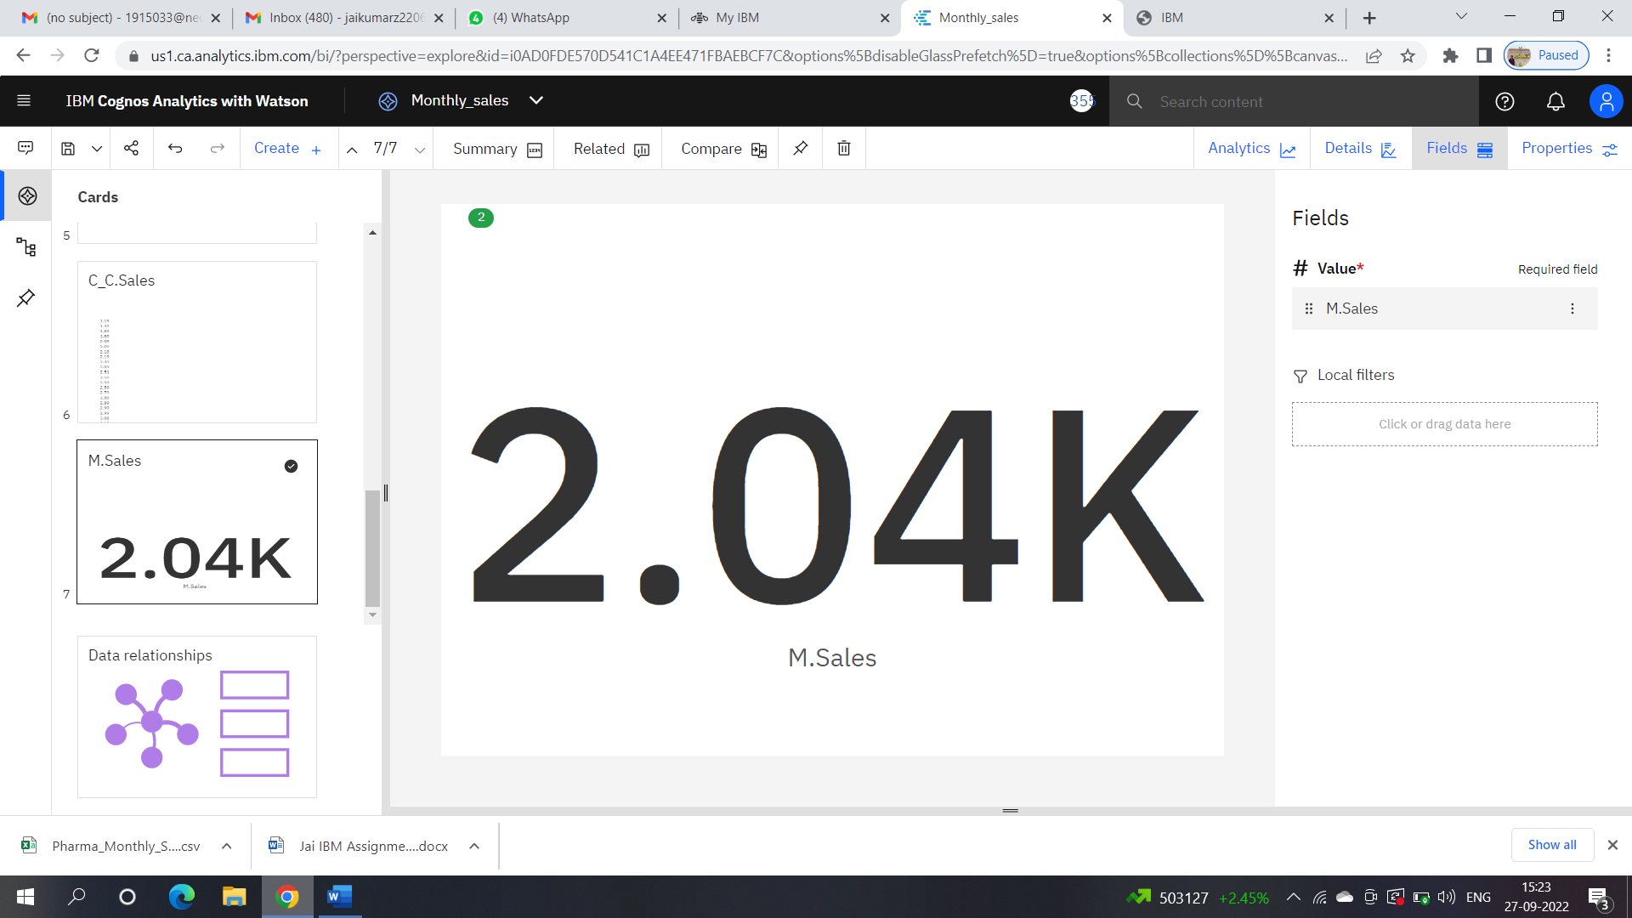

8 Actual and Received Inventory by Month <https://us1.ca.analytics.ibm.com/bi/?perspective=explore&pathRef=.my_folders%2FActual%2Bby%2BReceived%2BInventory%2Bsized%2Bby%2BMonth&subView=model000001837e5dcd3a_00000000>

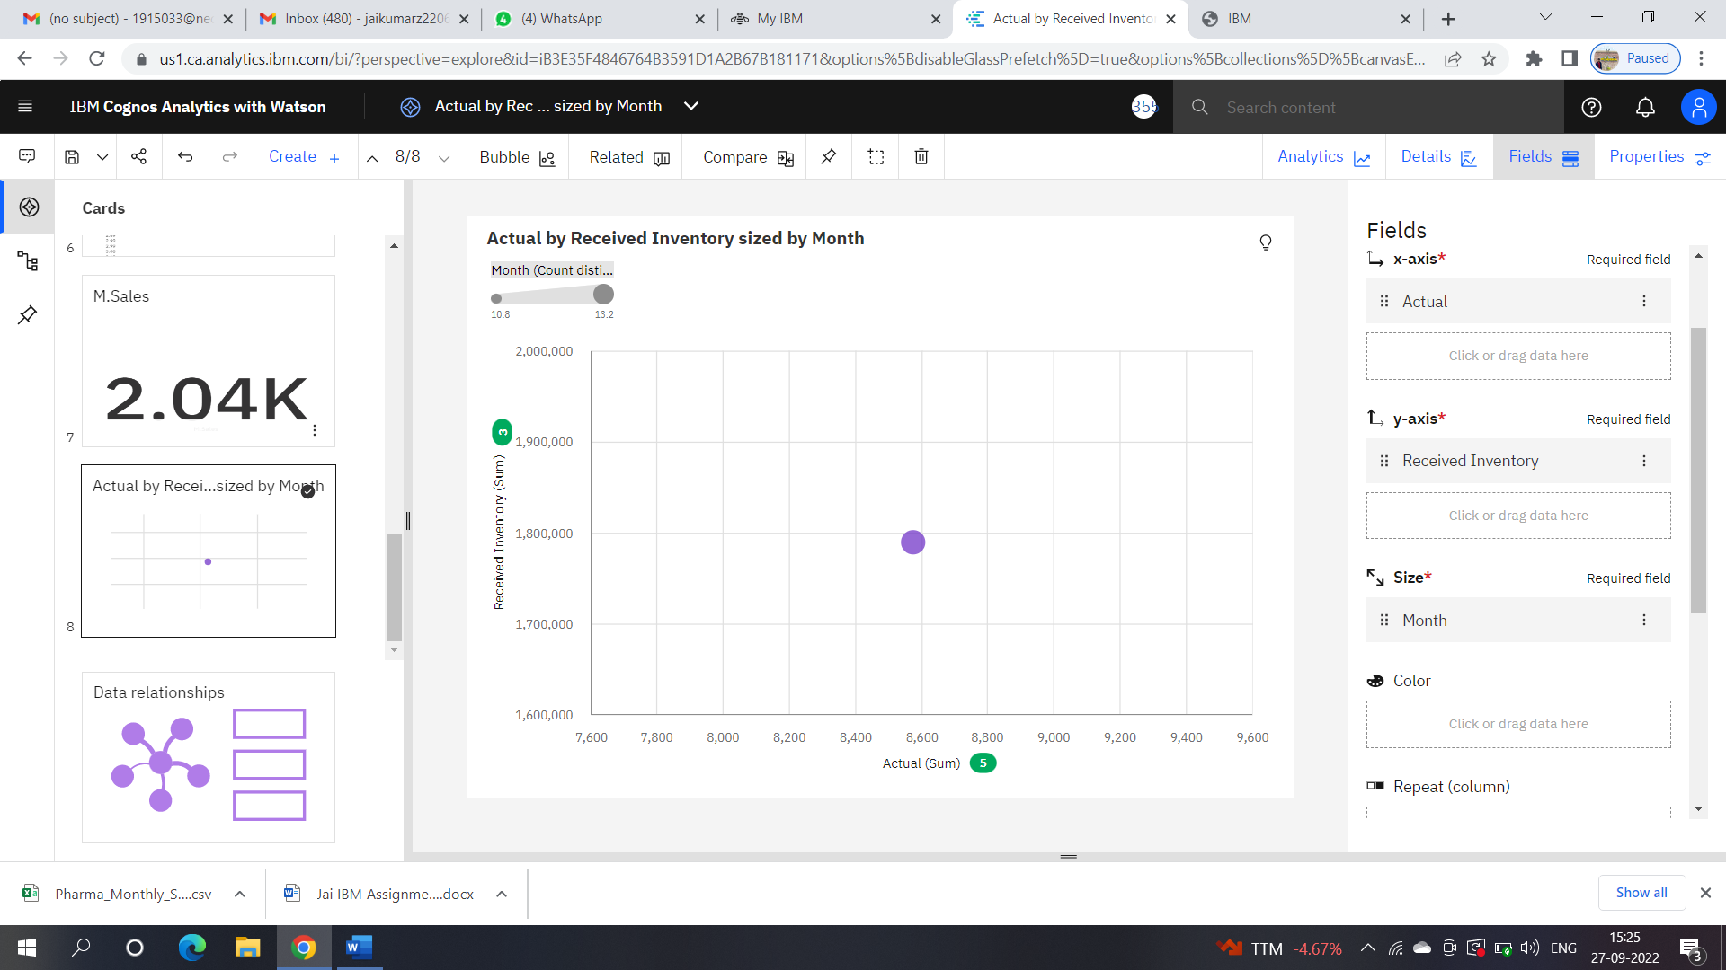

New Dashboard <https://us1.ca.analytics.ibm.com/bi/?perspective=dashboard&pathRef=.my_folders%2FNew%2Bdashboard&action=view&mode=dashboard&subView=model000001837e618bb1_00000002>

